HOME.LLC DATA SCIENCE(INTERN) OFFLINE TEST OUTPUT

**FACTORS THAT COULD INFLUENCE RESIDENTIAL HOME PRICES ACROSS THE UNITED STATES OVER THE NEXT 10 YEARS**

BY - IHECHILURU WINNER CHUKWUEMEKA

horizontal line

# 

# Introduction

# This report describes in a mutually exclusive and collectively exhaustive format all the factors that could influence residential home prices across the United States over the next 10 years.

## Brief

The Real estate market most especially residential homes and their prices are grossly influenced by a lot of things. Things like interests rates, population density changes, the economy, market cycles, consumer behaviour and the likes play key roles in influencing the prices of homes in any demographic region. For the sake of this report, I have restricted my analysis to just the united states.

### 5 Factors that Influence Prices of residential homes in the United States

1. Income: The average income of people living in a particular area is one of the most defining factors of the prices of homes in that area. Houses around major cities and states where people tend to earn more are usually also costlier than houses in rural areas.

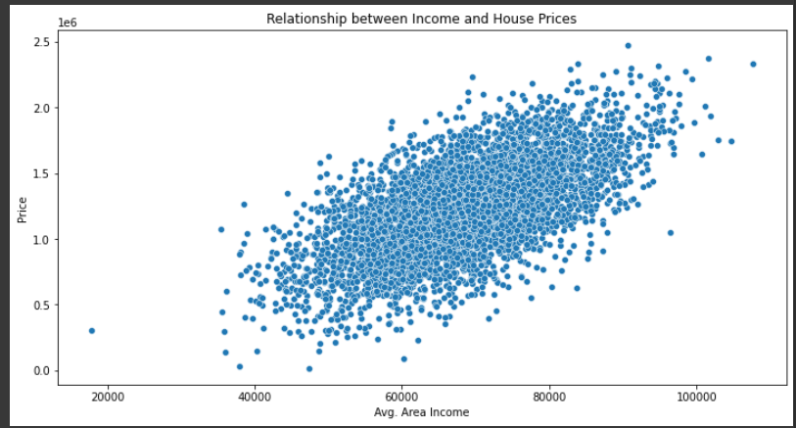

1. Location:

Residential houses are usually more costly where there are

1. Better Employment opportunities
2. More people (High population)
3. Close Malls, Entertainment centres, schools etc.

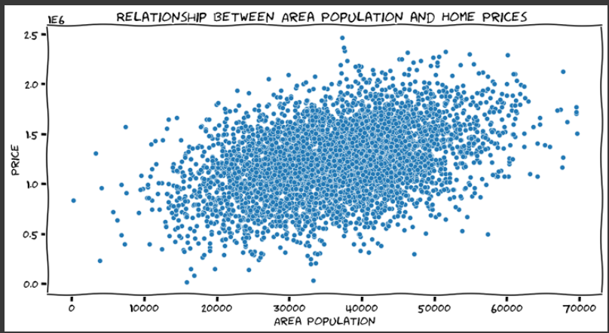

All these factors influence the houses of prices.

3. The general condition of the house:

People tend to be willing to pay more for houses that are in better condition. So, little factors like the state of the bulbs, fans, toilets, kitchen and all that can go a long way in determining the value of your house.

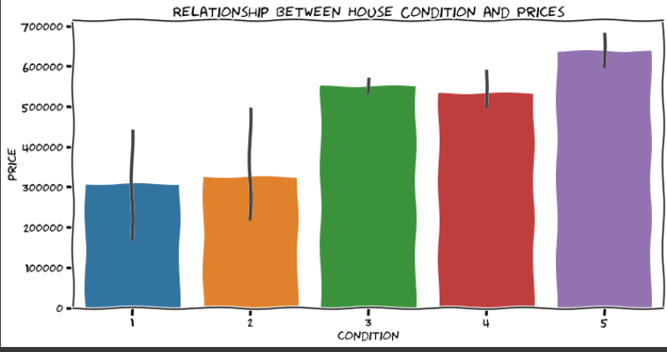

4. Number and Sizes of the rooms:

1. 1 bedroom Flats are on average, relatively the costliest flats. After that prices of residential apartments rise linearly from two to eight with its peak at eighth then falls back from 9 onwards.
2. The price of a house tends to increase with the number of bathrooms available. The sweet point is somewhere around 7 bathrooms
3. Even though people tend to pay more for houses with more floors. They are also other factors that would also affect the price.

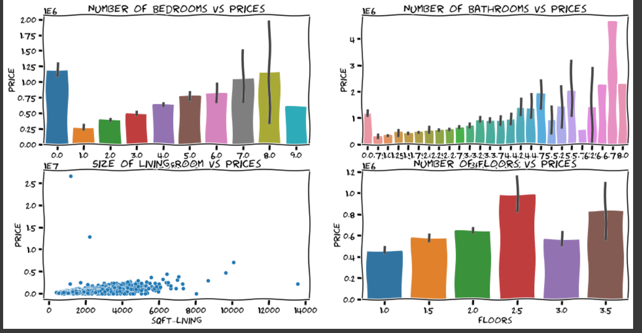

5. Age and State of the house: Houses that were built recently are usually costlier than older houses and people tend to pay more for houses that were just recently renovated.

6. Views and Aesthetics: Houses with beautiful views and waterfronts tend to be costlier.

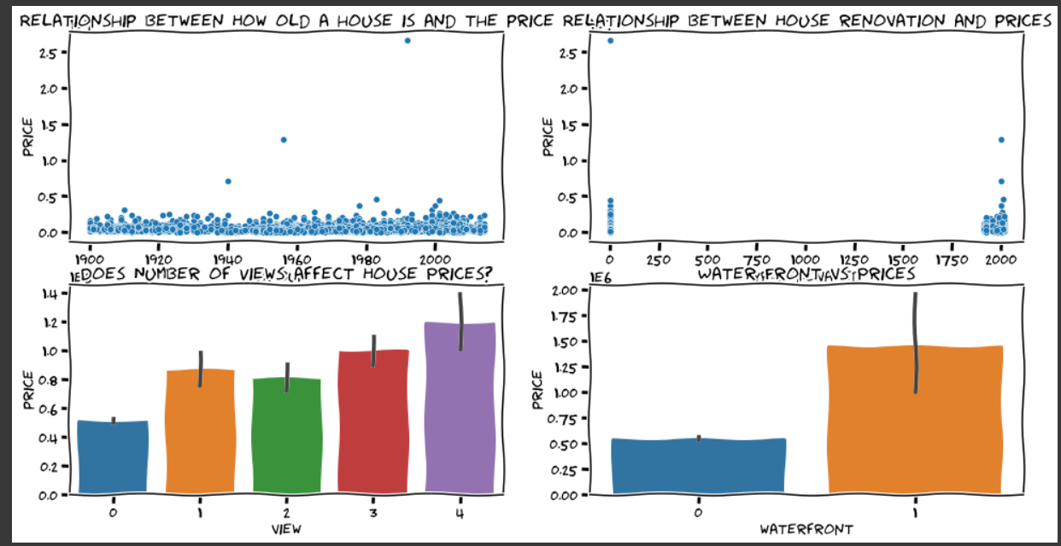

There are also other major influencing factors that might affect the price of residential houses such as the neighbourhood it’s in, the interests rates of the house, the current economy and so on.

Kindly access the file below if you’d like to view the code I used for the analysis behind my report.

<https://colab.research.google.com/drive/16RICyj7IApJcNX4ixqphPitCMV1S0xl9?usp=sharing>

Regards,

Ihechiluru Winner.